Assignment 1: Use Case

Yilong Yu – Ben Powers – [Jaehyun](javascript://) Park

8170995 – 7986250 – 8105702

System Analysis and Design / INFO2320

[David Turton](https://conestoga.desire2learn.com/d2l/le/content/229806/viewContent/4630975/View) / Sachin Parikh

September 24th, 2018

Team Name: Scoopy-doo Lab Section: 5

Teacher Name: ________________________

Due: Sep 24, 2018 6:00 PM

**Systems Analysis & Design – Assignment 1: Requirements & Use Cases**

You are working with the case **Spring Breaks ‘R’ Us** (**SBRU**) Travel Service. The four major subsystems of the solution being proposed are:

· Resort Relations

· Student Booking

· Accounting & Finance

· Social Networking

**Chapter 2 Questions (page 66)**

**1. Who are the stakeholders for SBRU? For each type of stakeholder, which subsystems of the SBRU booking system are of particular interest?**

Stakeholders are people who have an interest in the successful implementation of the system. There are four different categories according to their point of view of the project and it consists of internal, external, operational, and executive stakeholders on their own purpose.

* Internal Stakeholders of the SBRU booking system
  + Internal stakeholders are people within the organization. So, project owner, project leader, and team members can be internal stakeholders for this system and they might be interested in all subsystems because they are people who charge of the implementation of all four subsystems.
* External stakeholders
  + They are people outside the organization and resorts owners. Local Stores and restaurants in key spring break destinations can be external stakeholders because, even though they are outside the organization, they can have some benefits from the clients of the system. They will be interested in social networking subsystem and hope that they can have a chance to advertise their store through the subsystem.
* Operational stakeholders
  + People regularly interact with the system called operational stakeholders. One of the most important operational stakeholders in this system are clients. They will focus on student booking subsystem as a actual user and will be interested in usability, how it is convenient to use it compared to other similar systems, and how many nice resorts this system supply. Also, Resorts owners and MDs will be operational stakeholders connecting their resort to this system. They are interested in resort relations to add their resort on the system and accounting & finance to figure out how to make a deal with customer through the system.
* Executive stakeholders
  + They are people who don’t directly interact, but use the information or have financial interest. Business investors can be a good example for this type of stakeholders because they don’t have direct relation with the project but they are people who are really interested in business success. They will mostly care about accounting & finance subsystem.

**2. What are the main functional requirements for each of the four major subsystems?**

* Resort Relations
  + Create and register resort information including all rooms, facilities, and booking schedule
  + Check existed resort information
  + Edit and update existed resort information
  + Delete and unregister resort information
* Student Booking
  + Create account for SBRU system
  + Log In/Out to/from SBRU system
  + Edit student profile
  + Listing of all resorts which is available by trip schedule
  + Listing of available rooms and facilities of the resort chosen
  + View detail information of resort and rooms
  + Book rooms
  + Cancel or update booking
* Accounting & Finance
  + Payment from user
    - Payment by Credit Card
    - Payment by Debit Card
    - Payment by wire transfer (e.g. PayPal)
    - Payment by email money transfer
  + Payment to resort
    - Payment by Credit Card
    - Payment by Debit Card
    - Payment by wire transfer (e.g. PayPal)
    - Payment by email money transfer
  + Cancel and refund payment
  + Calculate and retrieve intermediary fee
  + Analysis payment statistics and estimate revenue
* Social Networking
  + Subscribe SBRU news thought famous Social Networking services (YouTube, Facebook, Instagram, and so on)
  + Post travel information including tourism attractions, local stores, and restaurants near the resort which user made a book
  + Online chatting between user and SBRU customer service

**3. Describe some usability requirements for student booking interactions and social networking interactions.**

The term “usability” in the context of creating software represents an approach that puts the user, rather than the system. So, we should make user-centered design using responsive web-tech. Also we can give users the mobility through mobile app.

Eventually, We might have to make users are able to feel comfortable when they use our system searching available resorts and rooms. Simplicity of user interface will be very important rather than adding a lot of utilities in SBRU system.

About social networking interactions, we can consider to integrate our social networking system to a lot of famous social networking systems like YouTube and Facebook. Or we can simply create SBRU account from existed famous social networking systems, then we will encourage users to subscribe SBRU account to be posted our news feed using their favorite Social Networking system.

**4. Assuming that social networking at the resorts will require wireless communication and connection to the Internet, what are some reliability requirements that resorts might be asked to maintain? What are some performance requirements? Is this a bigger issue because resorts are in international locations?**

SBRU to meet requirements of their customers must have these wireless communication requirements. For Reliability Requirements they must have fast internet connection speeds, secure WiFi and ethernet connections, safe protection that allows users the worry free of their personal devices getting hacked, and easy access to the internet with a simple password login. For Performance Requirements they must have a reliable internet connection that will not slow down due to high traffic or volume of users at one time accessing the internet. Also, maintaining a high speed connection allowing students for fast upload and download speeds at all times throughout the resort and also a strong WIFI connection allowing students to upload from anywhere in the resort making it convenient for them to use the SRBU application.

Since the resort is international it might be harder to find an internet company who can provide these high standards at high speeds. Once finding the proper internet provider i don’t see any other issues with the service.

**5. What are some security requirements? Is there any reason why students in Europe, Asia, or other locations could not book rooms through SBRU? What issues might be anticipated?**

Some simple security requirements would be allowing only students who purchased their trip through SBRU to access the application and also providing a safe and reliable connection while establishing a secure network connection to prevent hackers. Other students in different locations such as Europe, Asia, and other locations might encounter some language barriers and SBRU might want to allow a feature to allow users to change the language settings. Payments might be different as well for international students because payment methods could be quite different than North American standards.

**6. To collect information on functional requirements for the social networking subsystem, what are some techniques that might be used? Be specific and include some sample questions you might ask by using various techniques.**

* Create multiple surveys for SBRU users
  + How fast is our app?
  + Does our app experience any log in issues?
  + Would you recommend our app to your friends and family?
  + Rate our app 1-10
* Create an online help feature allowing users to interact with real people to fix their SBRU issues
  + How can I help you today?
  + Maybe try resetting your password?
* Making the app user friendly and easy to access and use
  + Allow users to access the app fast and easy
  + Giving user fingerprint scan to log in for easy access
  + Clean pages with minimal advertisements
* Add a messenger feature allowing users to send and receive text, image, and video messages
  + Allow user to upload videos and images at rapid high speeds
  + Giving user a clean interface to interact with their fellow SBRU students

**Chapter 3 Questions (page 91)**

1. Use the event decomposition technique for each event you can identify in the description of the *Booking* subsystem.

1. Name the event (as in who-does-what)
2. State the type of event (trigger type)
3. Name the resulting use case. Draw a use case diagram for these use cases.

|  |  |  |
| --- | --- | --- |
| **a. Event Name** | **b. Event Type** | **c. Use Case** |
| Student create account | External | Create Account |
| Student log in/out account | External | Log in/out Account |
| Student edit account profile | External | Edit Account |
| Student browse resorts | External | Display Resorts List |
| Student browse available rooms | External | Display Rooms List |
| Student book rooms | External | Booking Rooms |
| Student view booking details | External | Display Booking Details |
| Student enter payment subsystem | State | Entering Payment Subsystem |
| Student Cancel booking | External | Canceling Rooms |
| System send booking remind | Temporal | Sending Booking Remind |

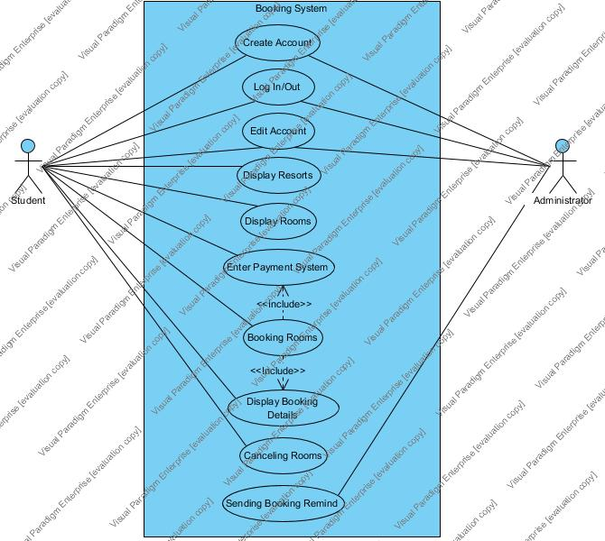

2. **Consider the new *Social Networking* subsystem that SBRU is researching. Think in terms of the user goal technique to identify as many use cases as you can think of that you would like to have in the system. SBRU is guessing you might want to join, send messages, and so forth, but there must be many interesting and useful things the system could do before, during, and after the trip. Draw a use case diagram for these use cases.**

Social Networking subsystem is a significant component of the functional application like SBRU. It can enhance the customer loyalty and user activeness. It also offers a platform for students and resorts: students share their experience, resorts show their attraction. After the group discussion, we lists Use Cases that are shown in the Use Case Diagram below.

